Report of GWB 2024(India)
IUPAC “Global Women Breakfast”
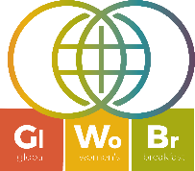

Global Women Breakfast(GWB) is a global and prestigious event which is organized every year by IUPAC in association with prestigious chemical societies and institutions (Royal Society of Chemistry, American Chemical Society, DE GRUYTER, BAYER and Royal Australian Chemical Institute (RACI)) to celebrate the achievements of women and girls in Science.

The Association of Chemistry Teachers (India)(Mailing Address: Homi Bhabha Centre for Science Education (TIFR) Mumbai) has been promoting and coordinating GWB in India since 2021.Assciation of Chemistry Teachers (India) is the national registered organization of Chemistry educators of India and since its inception in 2000,has been promoting excellence in Chemistry education and research.

This year, 78 institutions, colleges and universities from different parts of India registered for the event and organized several activities like e-Symposia, National and International Seminars, workshops, conferences and awareness programs at national and international levels to celebrate GWB 2024, on 27 Feb. 2024 with the theme “Catalyzing Diversity in Science” announced by IUPAC for 2024. This year the maximum registrations were from India and our country secured top position in the world.

Prof. Brijesh Pare (President,ACT) Head, Department of Chemistry, Govt. Madhav Science PG, College, Ujjain served as the Convener and Dr. Vijendra Singh, Assistant Professor, Department of Chemistry, Institute of Science and Research (ISR) IPS Academy, Indore as National Coordinator of GWB-2024 for India.

Dr. DV Prabhu (General Secretary, ACT ),Former Head, Department of Chemistry, Wilson College,Mumbai promoted GWB along with all the executive members and life members of ACT from different zones of India.

Some Glimpses of GWB-2024 in India
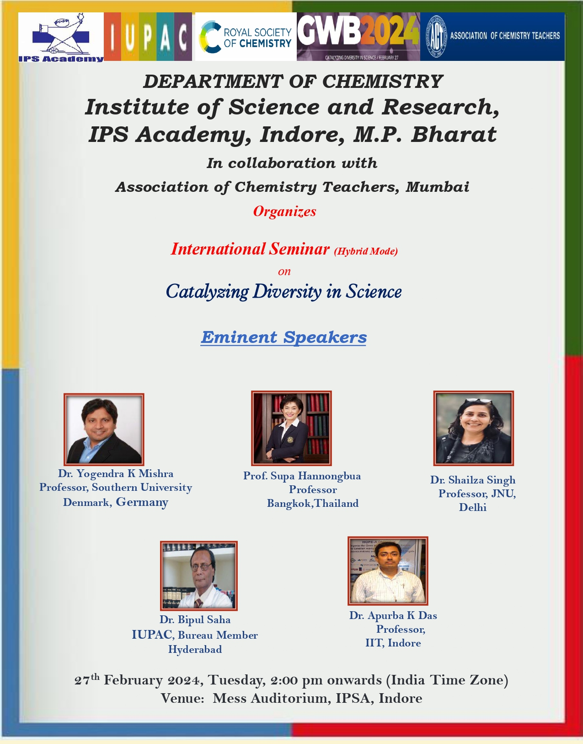
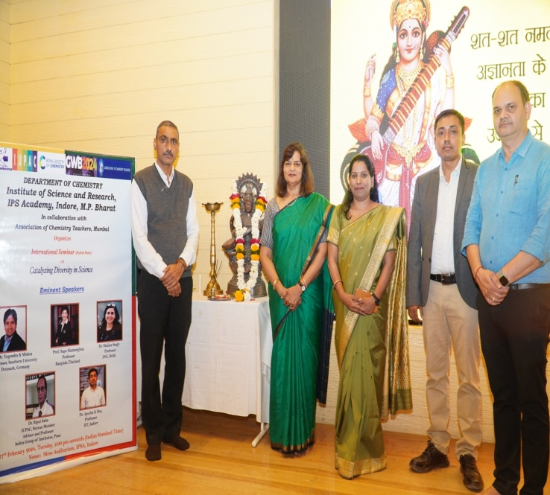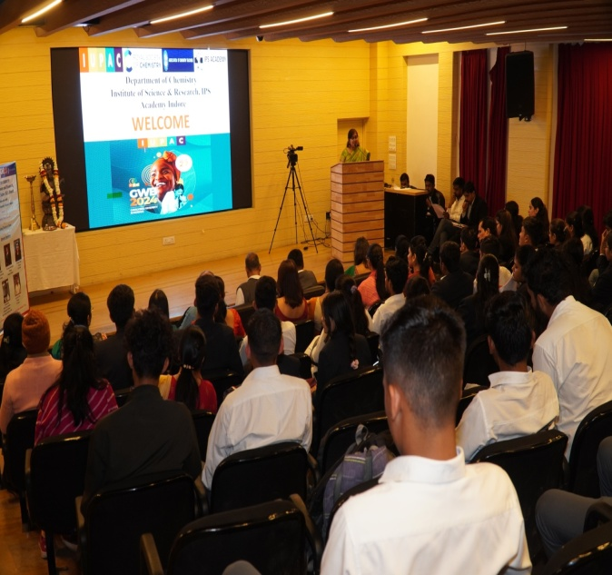
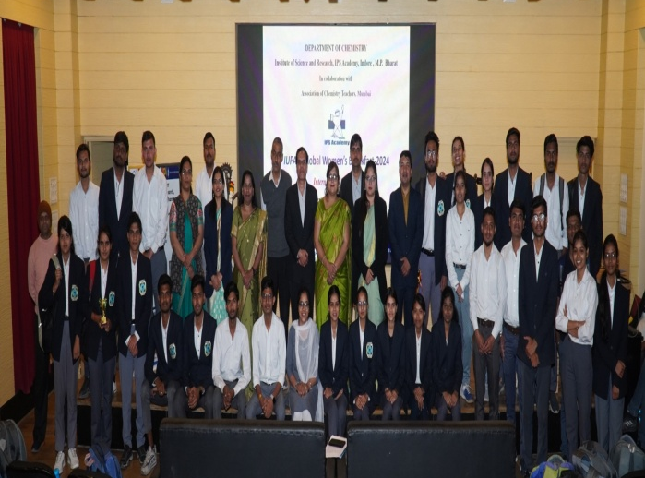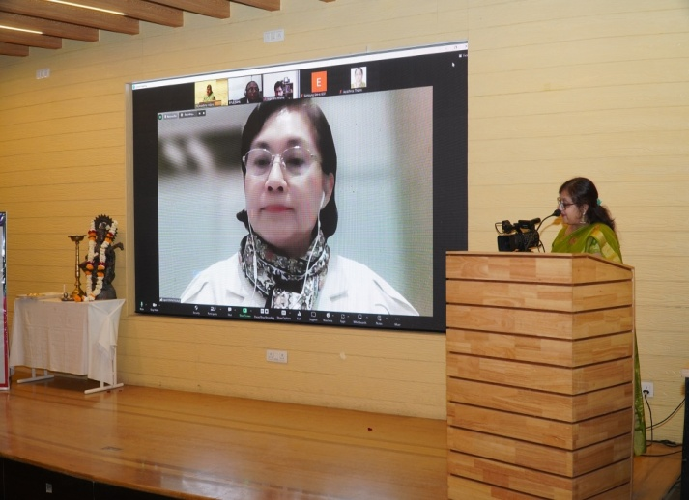
Department of Chemistry, ISR, IPS Academy, Indore,MP

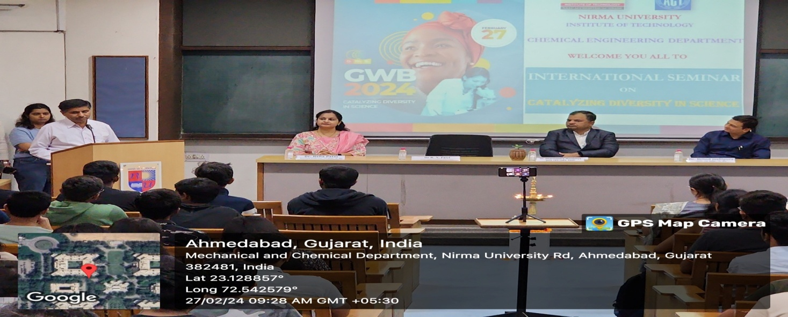
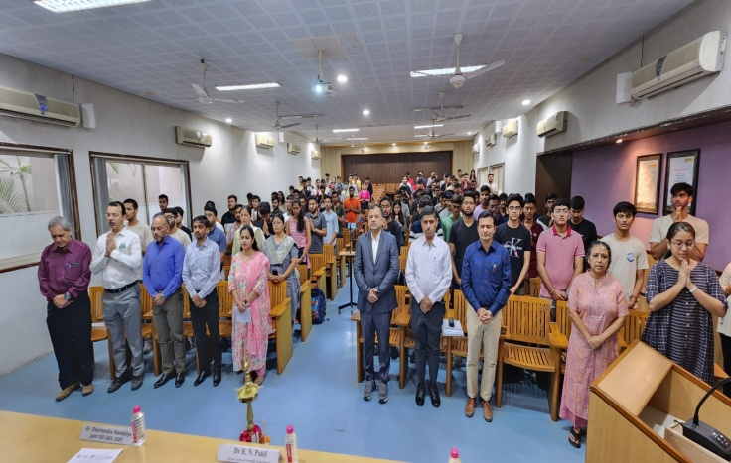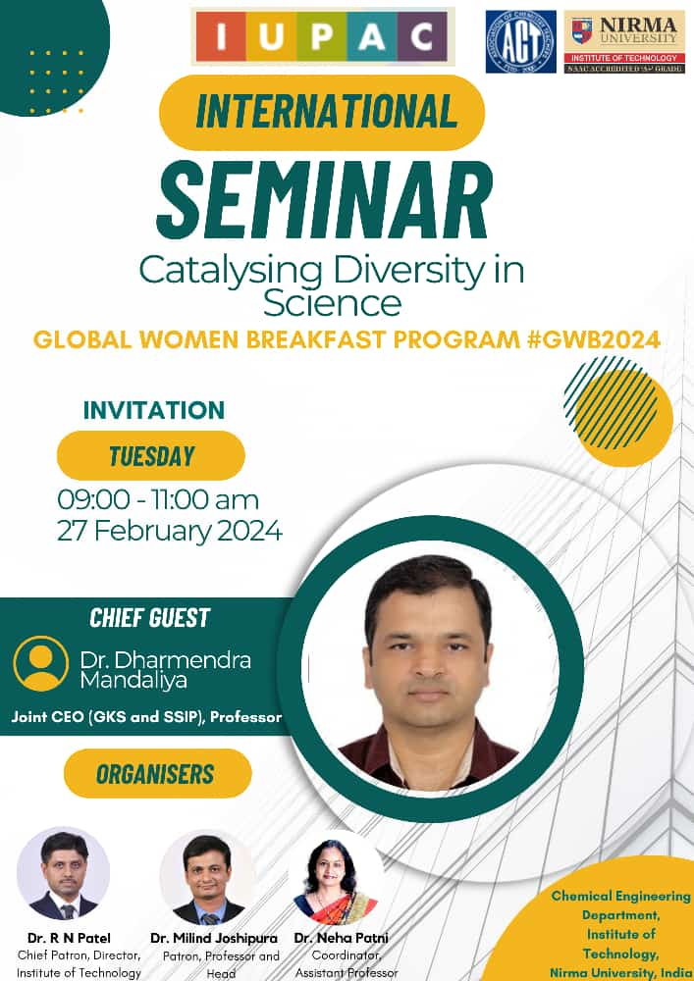
Department of Chemistry,NIRMA University,Ahmedabad,Gujarat
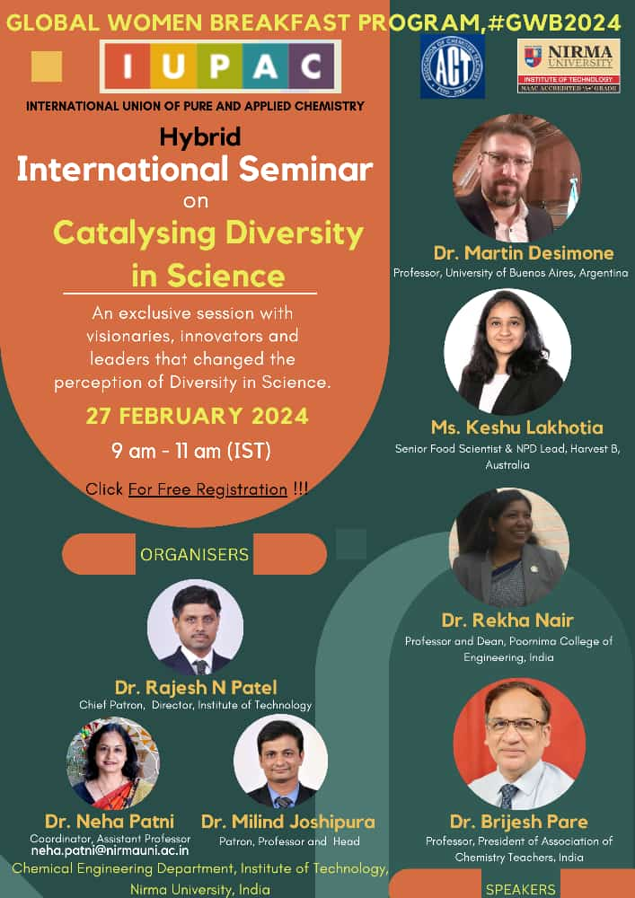Department of Chemical Engineering, NIMS University, Gujarat

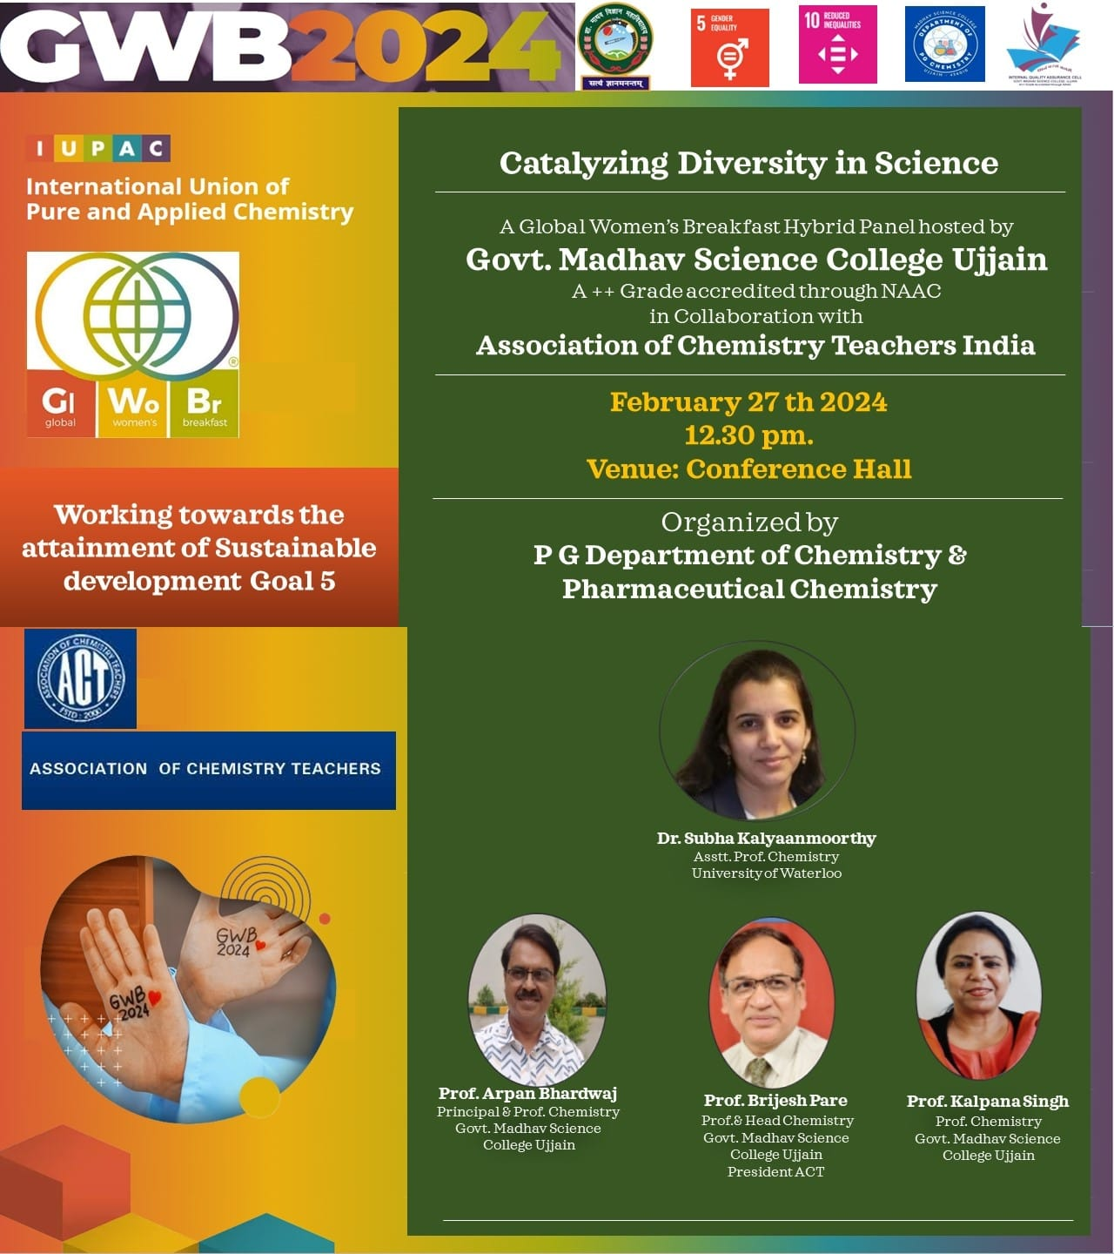
Department of Chemistry, Govt. Madhav Science College, Ujjian, MP
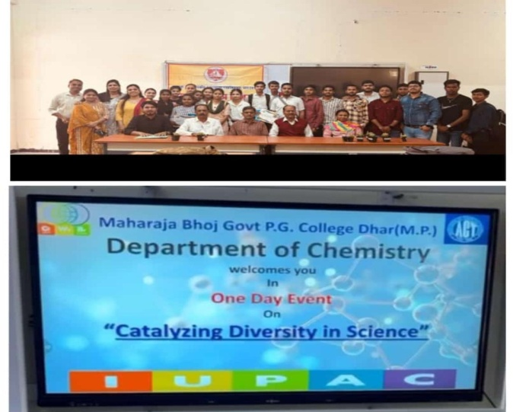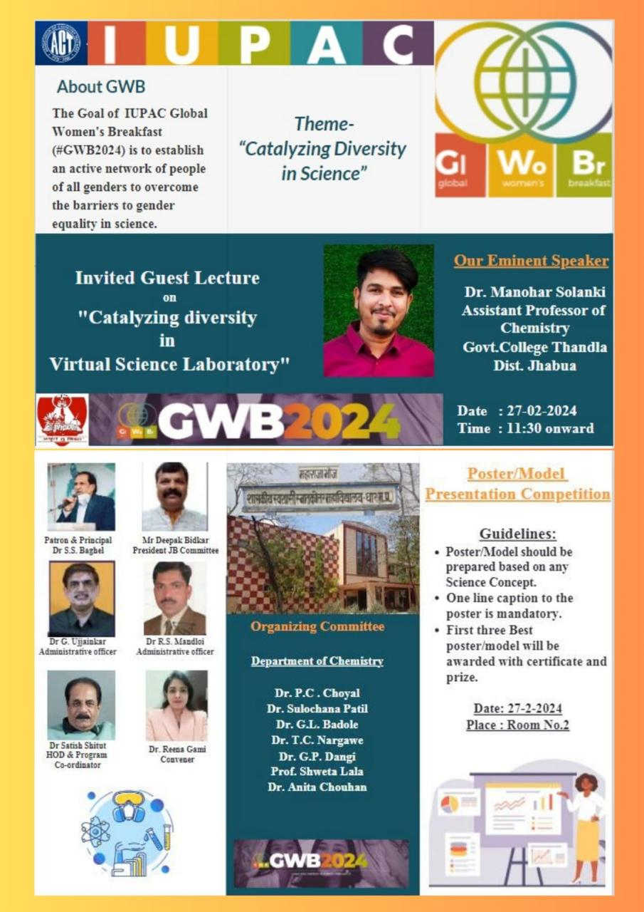
Department of Chemistry, Govt. PG College, Dhar, MP

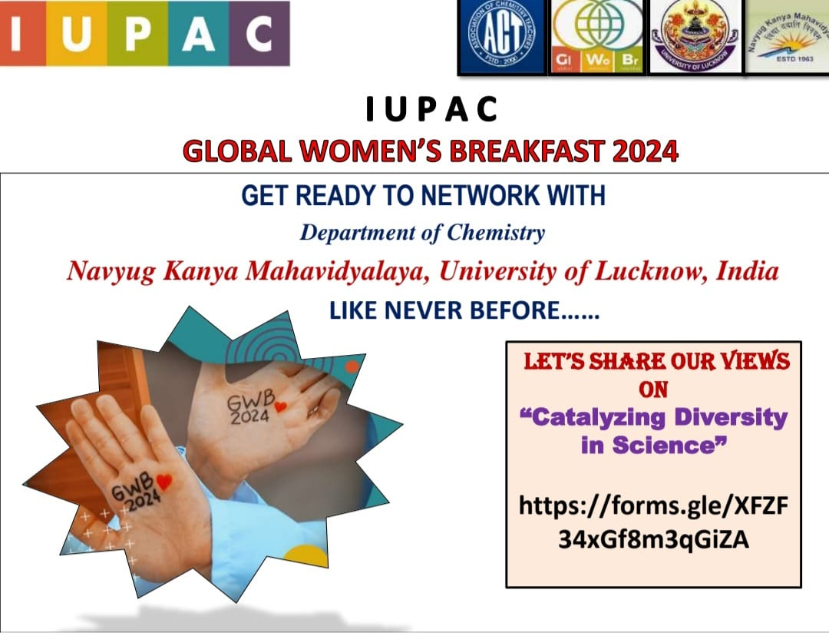
Department of Chemistry, Navyug Kanya Mahavidhyalaya, Lucknow, UP.

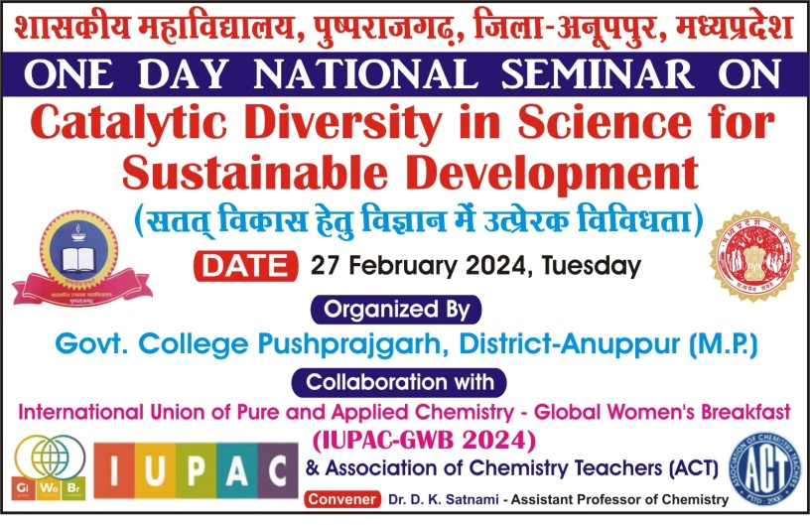Department of Chemistry, Govt. College, Pushparajgarh, MP.

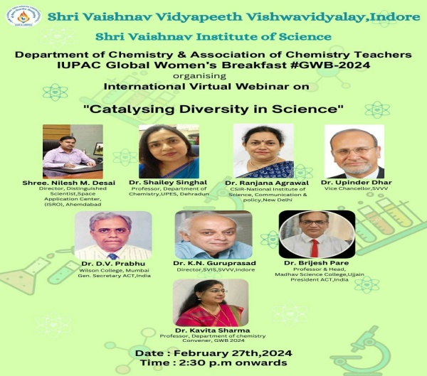
Department of Chemistry, SVVV, Indore, MP.
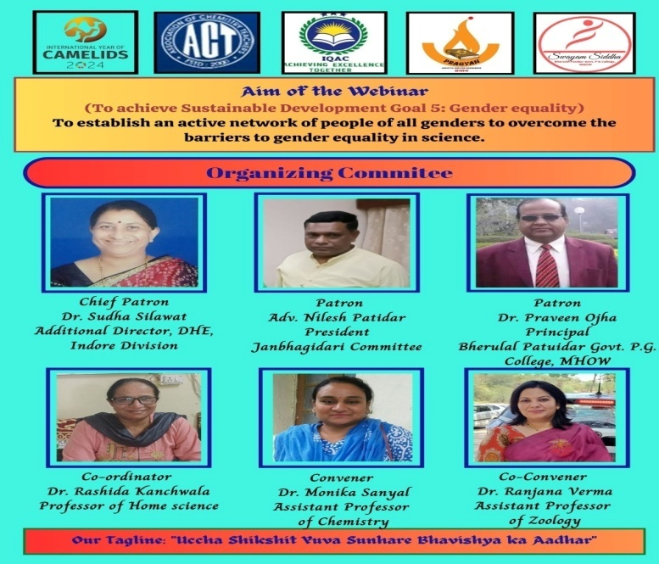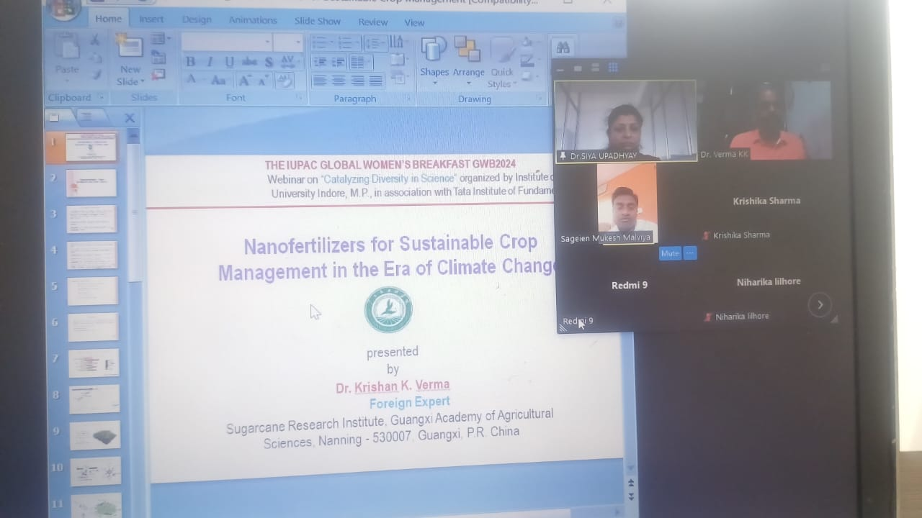
Department of Chemistry, B.L.P. Govt. PG College, Mhow, MP.
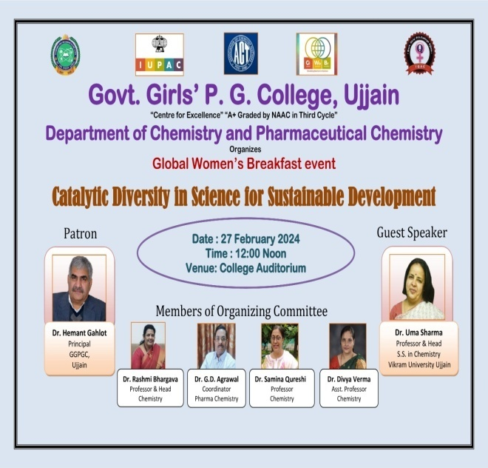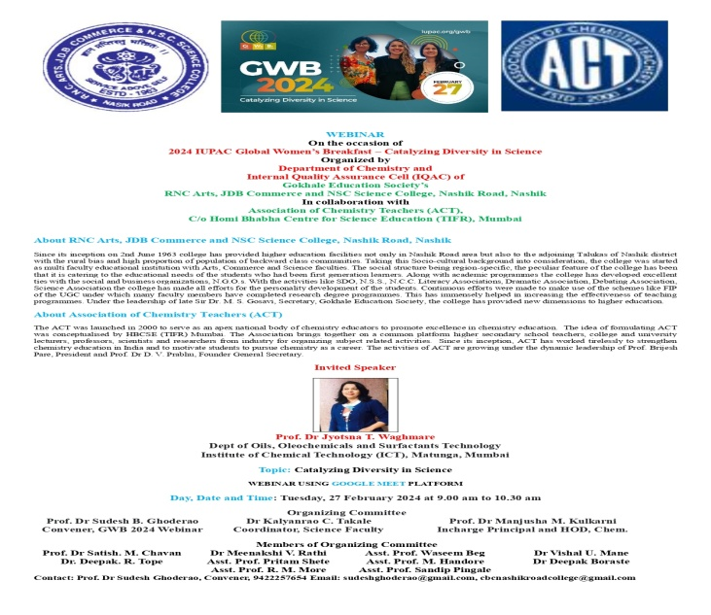
Department of Chemistry, Govt. Girls, PG College, Ujjain, MP.
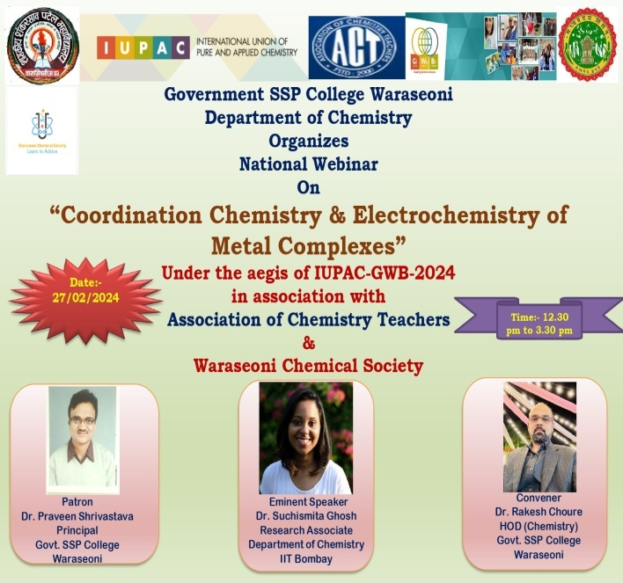
Department of Chemistry, Govt. SSP College Waraseoni, MP.

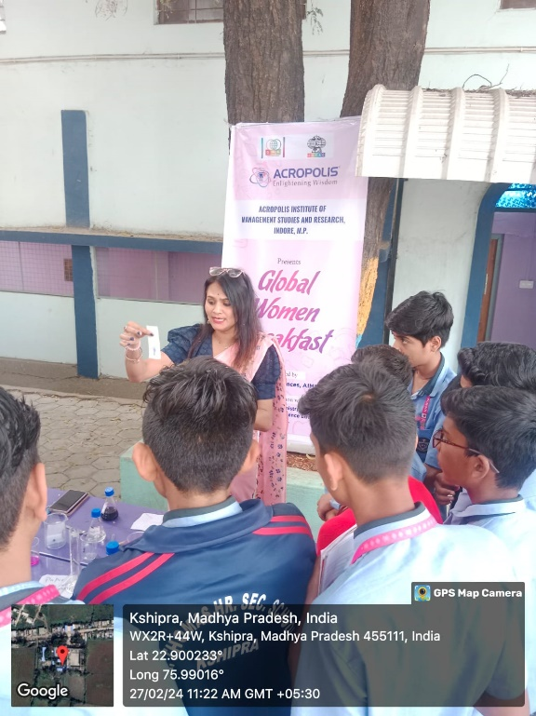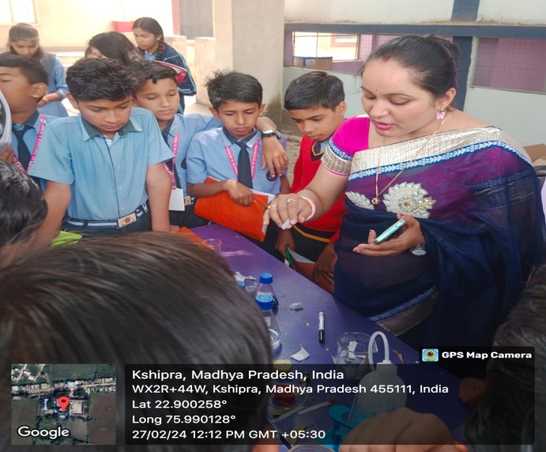
Department of Biosciences, AIMSR, Indore, MP.
Maulana Azad College of Arts, Science and Commerce, Aurangabad, Maharashtra, India
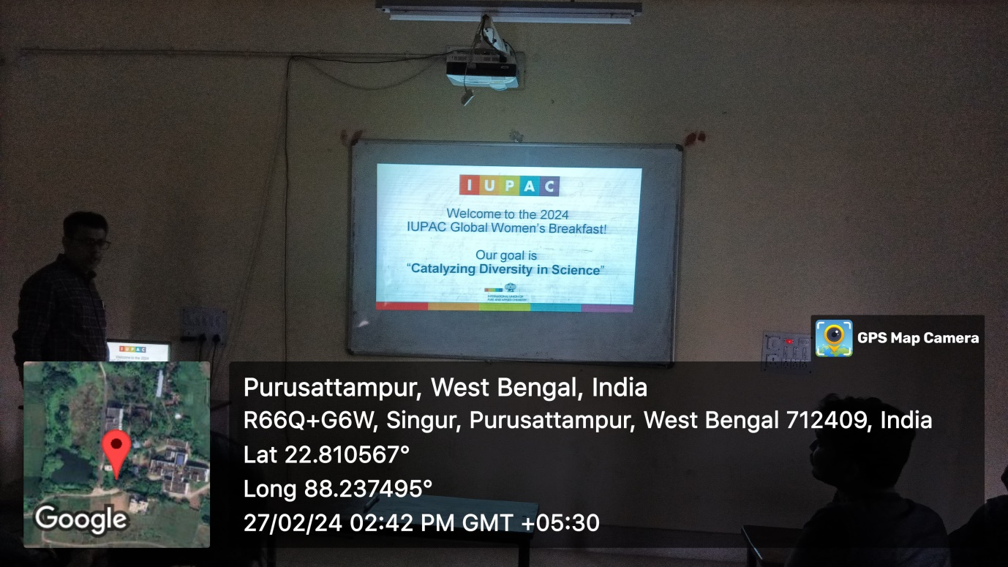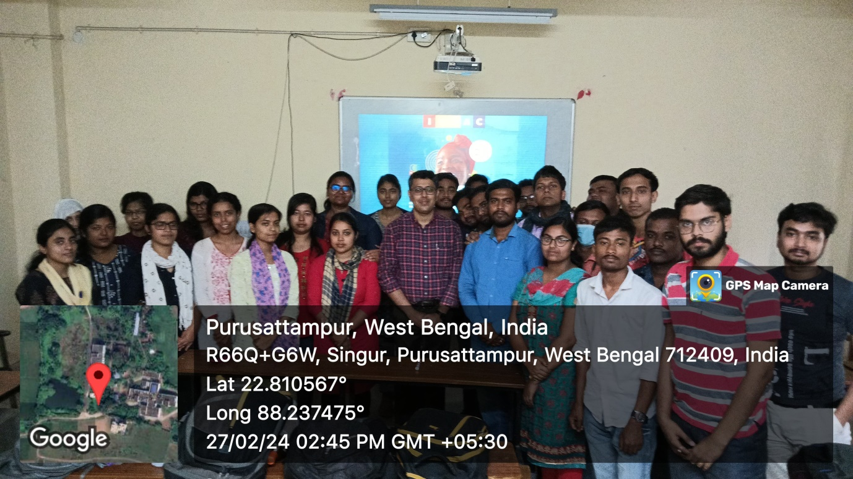
Department of Chemistry
Government General Degree College, Singur,West Bengal

